Reception | Autumn |  | Spring |  | Summer
Core text/book stimulus | 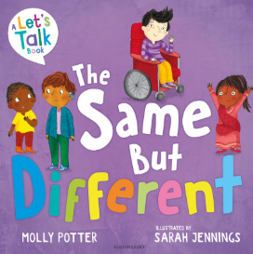 | 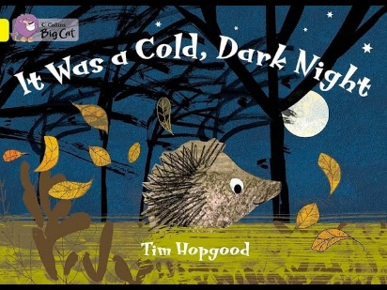 | 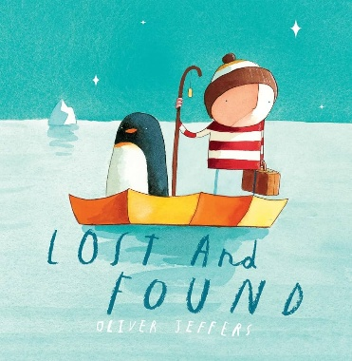 | 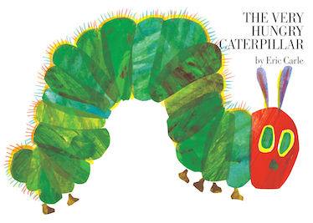 | 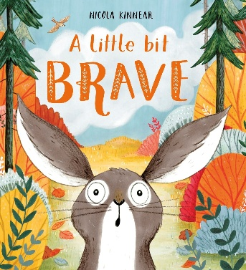 | 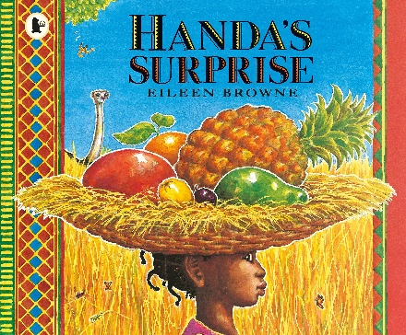
Core text/book stimulus | 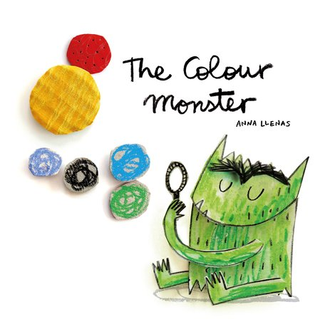 | 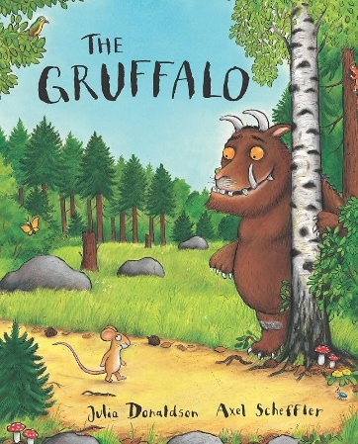 |  | 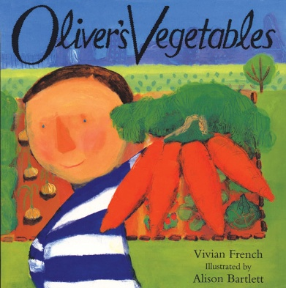 | 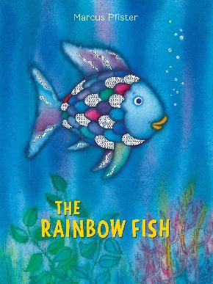 | 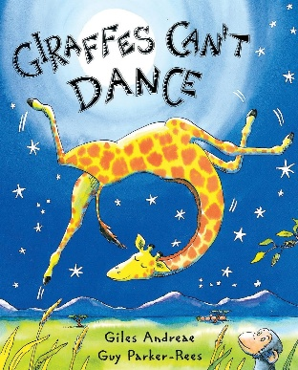
Core text/book stimulus | 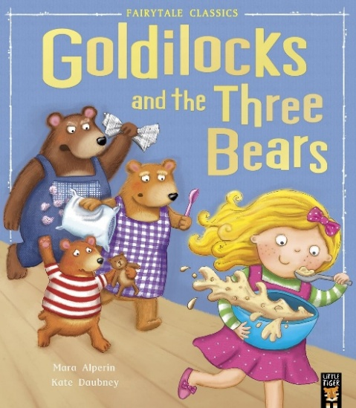 | 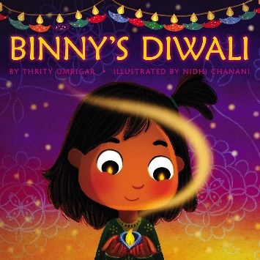 | 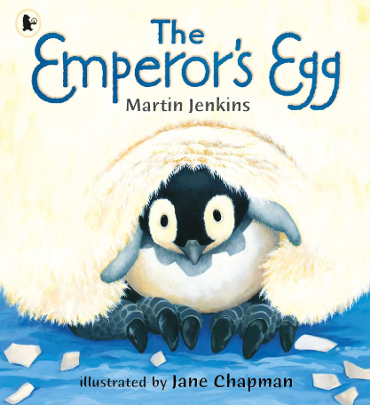 |  | 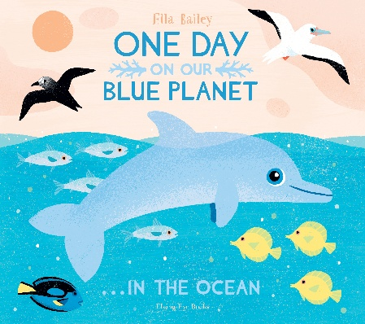
Core text/book stimulus |  | 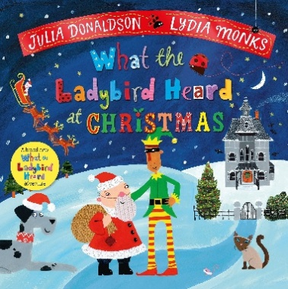
Poems and rhymes | If you’re happy and you know it  Days of the week  Polly put the kettle on  Wind the bobbin up  Incy wincy spider  Two little dickie birds | Five Little Men in a Flying Saucer  I’m a little teapot  Old McDonald had a farm ‘  Miss Polly had a dolly  Three blind mice | Five Current Buns  This Old Man  Five little monkeys jumping on the bed  Five little speckled frogs  Hickory dickory dock | Mary had a little lamb  One, Two Buckle my shoe  Ten green bottles  The Grand Old Duke of York  Mary, Mary Quite Contrary | London Bridge  Little Miss Muffet  Down in the Jungle  Here we go round the mulberry bush  Ten in the bed | My Bonnie lies over the ocean  Are you sleeping? Are you sleeping?  Oranges and lemons  The animals went in two by two  Ten fat sausages

