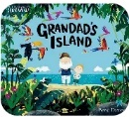
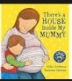
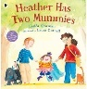
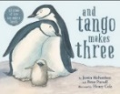

Age
Sexual orientation
Spring 1
Autumn 2
Spring 2
Summer 1
Spring 2
Pregnancy and maternity
Summer 1
Spring 2
Spring 1
Spring 1
Spring 1
Autumn 2
Summer 2
Autumn 2
Autumn 1
Spring 2
Spring 1
Autumn 1
Summer 2
Year 4
Autumn 1
Summer 2
Year 3
Autumn 2
Autumn 1
Spring 1
Summer 1
Autumn 2
Autumn 1
Summer 2
Summer 1
Year 5
Year 1/2
Year 6

Personal Development Reading Map
EYFS

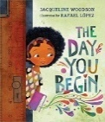
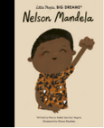

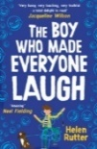
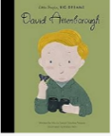
Race
Race, religion or belief
Individual Liberty
Race
Tolerance of Those with Different Faiths and Beliefs
Disability
Mutual Respect
Age
Individual Liberty
Mutual Respect & Tolerance

Mutual Respect
Tolerance of Those with Different Faiths \and Beliefs
Summer 2
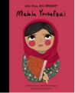
Spring 2
Sex, age, religion or belief, race
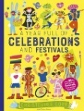

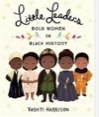
Mutual Respect & Tolerance
Individual Liberty
Democracy
Disability
Race, Religion or belief
Individual Liberty
Religion or belief, race, age,
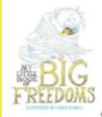
Mutual Respect
Mutual Respect & Tolerance
Mutual Respect
Tolerance of Those with Different Faiths and Beliefs
Individual Liberty
Tolerance of Those with Different Faiths and Beliefs
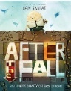

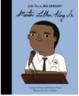
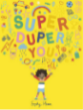
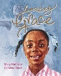
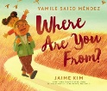
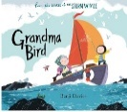
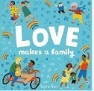
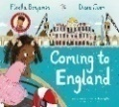
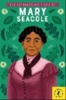
Disability
Race, sex
Age
Autumn 1
Race, religion or belief, disability, sex, age
Race
Sexual orientation
Summer 1
Race
Mutual Respect & Tolerance
Individual Liberty
Democracy

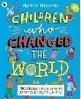
Individual Liberty
Age
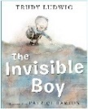

Sex
Spring 2
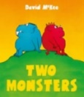
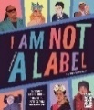
Mutual Respect
Individual Liberty

Sexual orientation, disability, sex
Democracy
Mutual Respect

Mutual Respect
Rule of Law
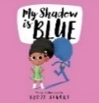

Individual Liberty
Gender reassignment
Sex
Individual Liberty
Summer 2
Summer 1
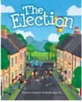
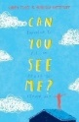
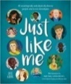
Democracy
Rule of Law
Disability

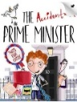
Religion or belief, race, age,
Disability
Mutual Respect
Democracy
Tolerance of Those with Different Faiths and Beliefs
Individual Liberty

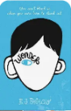
Disability
Mutual Respect
Tolerance of Those with Different Faiths and Beliefs
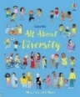
Marriage and Civil Partnership, sexual orientation
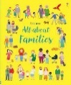
Tolerance of Those with Different Faiths and Beliefs
Mutual Respect
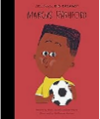
Race
Individual Liberty
Sexual orientation, age, disability, race
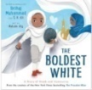
Race, Religion or Belief
Mutual Respect & Tolerance
Autumn 2
Mutual Respect
Tolerance of Those with Different Faiths and Beliefs


Rule of Law

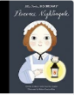
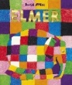
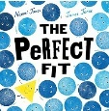
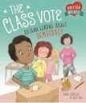
Disability
Individual Liberty

Sex
Individual Liberty
Democracy

Race
Individual Liberty
Mutual Respect
Individual Liberty
Race, sex


Gender reassignment

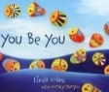
Individual Liberty
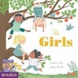
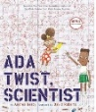
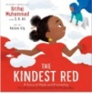
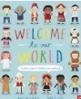

Race, sex
Race
Religion or Belief
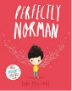
Individual Liberty
Mutual Respect
Individual Liberty
Mutual Respect
Mutual Respect
Mutual Respect
Race
Sex

Tolerance of Those with Different Faiths and Beliefs
Mutual Respect
Individual Liberty
Individual Liberty

Tolerance of Those with Different Faiths and Beliefs
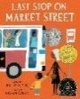
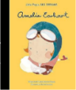
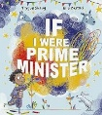


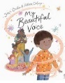
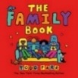
Marriage and Civil Partnership, Sexual orientation
Race, sex
Rule of Law
Individual Liberty
Individual Liberty
Race
Marriage and Civil Partnership, sex, age, religion or belief, race
Sex
Democracy
Mutual Respect & Tolerance
Mutual Respect & Tolerance
Mutual Respect
Individual Liberty
Mutual Respect & Tolerance
Rule of Law
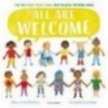
Mutual Respect & Tolerance
Marriage and Civil Partnership, sex, race, sexual orientation
Mutual Respect & Tolerance

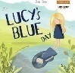
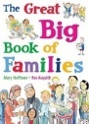
Sexual orientation, Pregnancy and maternity
Mutual Respect & Tolerance
Race
Mutual Respect & Tolerance
Disability
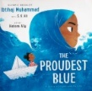
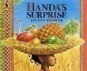
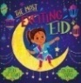
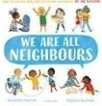
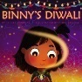
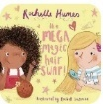
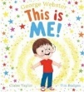
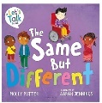
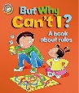
Mutual Respect & Tolerance
Race
Religion or Belief
Mutual Respect & Tolerance
Race

Religion or Belief
Mutual Respect & Tolerance
Mutual Respect & Tolerance
Race, Religion or Belief
Religion or Belief
Mutual Respect & Tolerance
Mutual Respect & Tolerance
Race

Mutual Respect & Tolerance
Individual Liberty
Race, religion or belief
Disability
Individual Liberty
Individual Liberty
Rule of Law

