Royston 2026 Headline Data

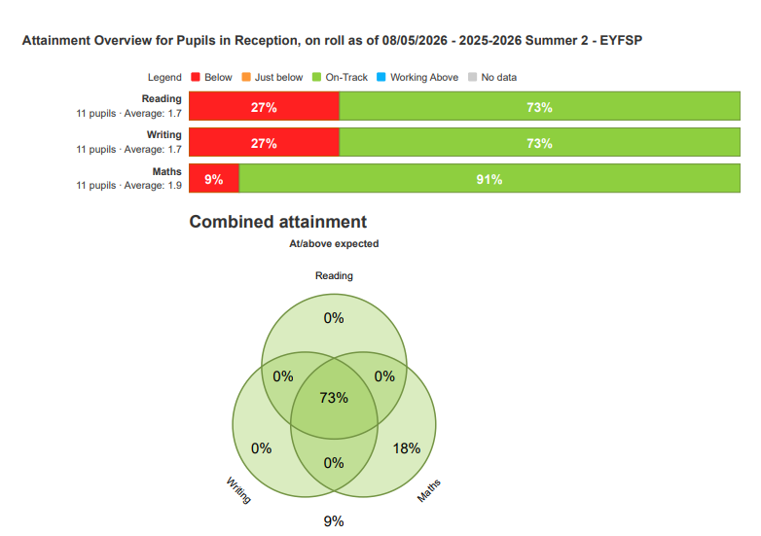
EYFS Data

Year 1 phonics
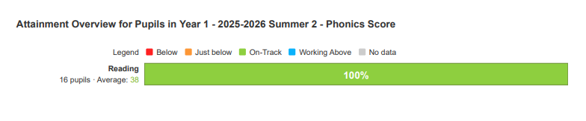

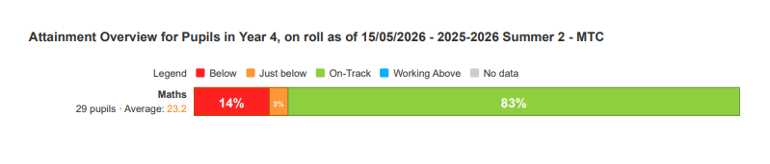
Year 4 Multiplication Check

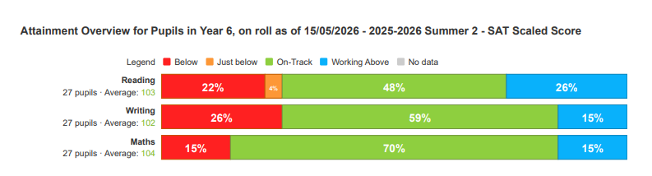
Year 6 Data

