Year 6 | Autumn |  | Spring |  | Summer
Whole Class Reading Text  (Fiction) | Letters from the Lighthouse | Alice in Wonderland – Lewis Caroll | Kensuke’s Kingdom by Michael Morpurgo | Boy at the Back of the Class | Friend or Foe | The Final Year
Whole Class Reading Text  (Fiction) | 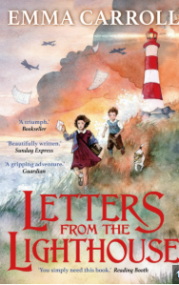 | 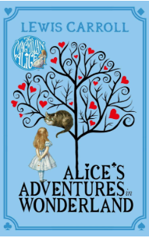 | 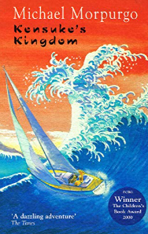 | 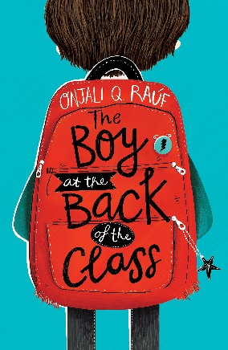 | 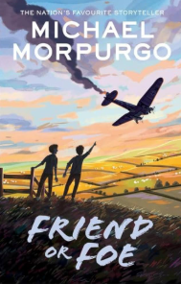 | 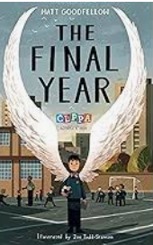
Non-fiction Focus Text | Hidden Figures  Non-chron  (Black History Text)  Unit 3 | Deforestation  Leaflet  Unit 17 | Malala Yousafzai  Newspaper article  Unit 11 | Marius the Giraffe  Newspaper article  Unit 20 | Charles Darwin  Biography  Progress check 3 | Evolution Revolution  Scientific book  Unit 21
Poetry (comprehension) | Asgard  Greek Gods  Unit 2 | For the Fallen  Remembrance Day  Unit 6  Performance poetry comp |  | The Hunting of the Snark  Progress check 2 |  | The British  British Empire  Unit 4
Poetry (pleasure) | Sensational poems book  In Flanders Field by John McCrae  Spin poetry book
Reading for pleasure | The Girl of Ink and Stars  Orphans of the Tide

