Year 5 | Autumn |  | Spring |  | Summer
Whole Class Reading Text  (Fiction) | The Explorer by Katherine Rundell | Holes by Louis Sachar | The Boy in the Tower | Who Let the God’s Out? By Maz Evans | The Nowhere Emporium By Ross Mackenzie | Harry Potter and the Philosopher’s Stone by JK Rowling
Whole Class Reading Text  (Fiction) | 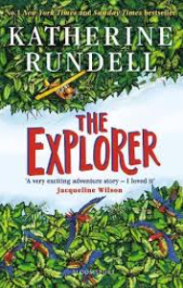 | 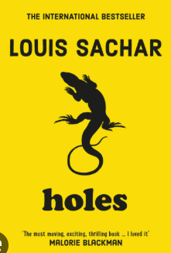 | 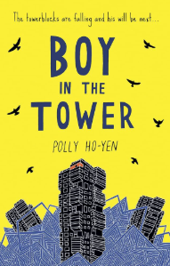 | 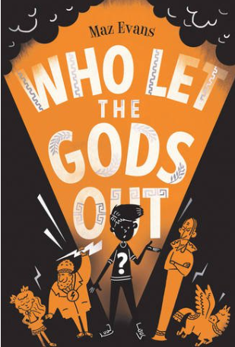 | 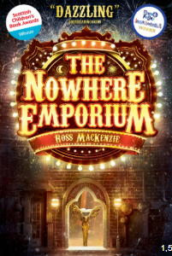 | 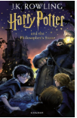
Non-fiction Focus Text | Dragonology  Fictional guide written in a non-fiction format  Unit 1 | Life in Tudor Britain  Non chronological report  Unit 3 | SeaWorld  Newspaper article  Unit 11 | Who are Refugees and Migrants  First person perspective  Progress Check 2 | Harry Houdini  Biography  Unit 17 | Plague  Non chronological report  Unit 19
Poetry (comprehension) | Love Letter  Unit 4 | Performance poetry week | Once Upon a Star  Unit 16
Poetry (pleasure) | The World’s Greatest Space Cadet by James Carter  Let’s chase stars together book  Our Earth is a poem book
Reading for pleasure | Pig Heart Boy  Artemis Foul  Dial a Ghost

