Year 4 | Autumn |  | Spring |  | Summer
Whole Class Reading Text  (Fiction) | Charlie and the Chocolate Factory by Roald Dahl | Chronicles of Narnia: The Lion the Witch and the Wardrobe by C.S Lewis | The Firework Maker’s Daughter | Wonder | How to Train Your Dragon | Land of Roar
Whole Class Reading Text  (Fiction) | 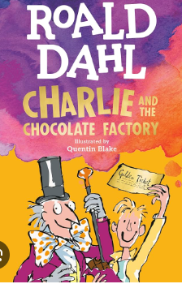 | 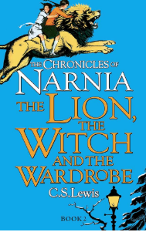 | 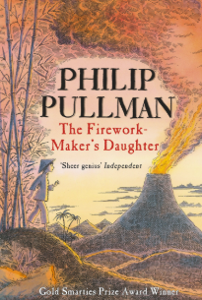 | 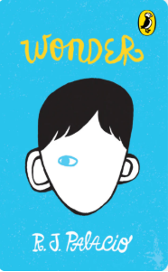 | 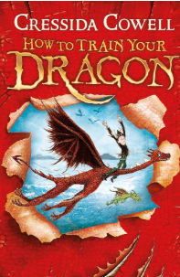 | 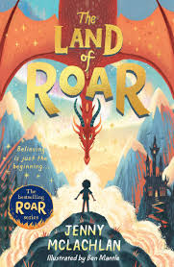
Non-fiction Focus Text | Roman Britain  Non chronological report  Unit 1 | The History of Christmas Traditions  Newspaper article  Unit 7 | Volcanoes in Action  Non chronological report  Unit 3 | Tsunamis on the Move  Non chronological report  Unit 4 | Heatwave Raises ‘Lost Atlantis’ Village  Newspaper article  Progress check 2 | Threats to African Elephants  Persuasive text  Unit 16
Poetry (comprehension) | Russian Doll  Unit 5 | Performance poetry week |  | For Forest  Unit 9
Poetry (pleasure) | My heart is a poem book  Please Mrs Butler poems  Cloud Busting: Puffin Poetry book
Reading for pleasure | Bills New Frock  The Girl Who Wasn’t There  Toad Rage

