Year 3 | Autumn |  | Spring |  | Summer
Whole Class Reading Text  (Fiction) | The Girl Who Became a Fish | Charlotte’s Web by E.B White | The Nothing to See Here Hotel | Fantastic Mr Fox | The Boy Who Grew Dragons | You’re a Bad Man Mr Gum by Andy Stanton
Whole Class Reading Text  (Fiction) | 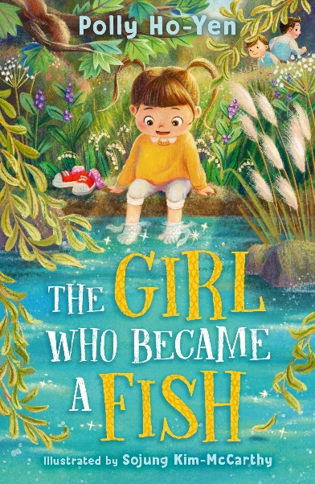 | 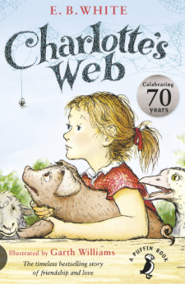 | 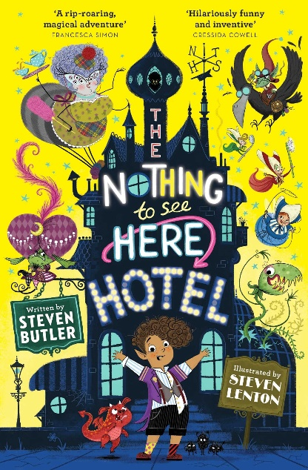 | 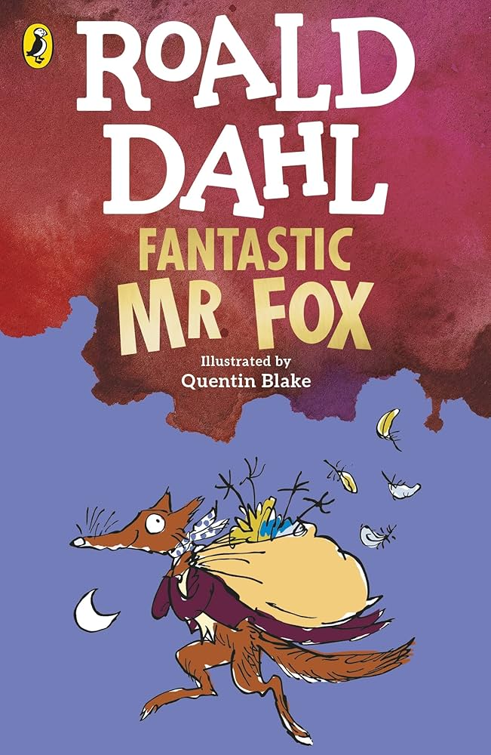 | 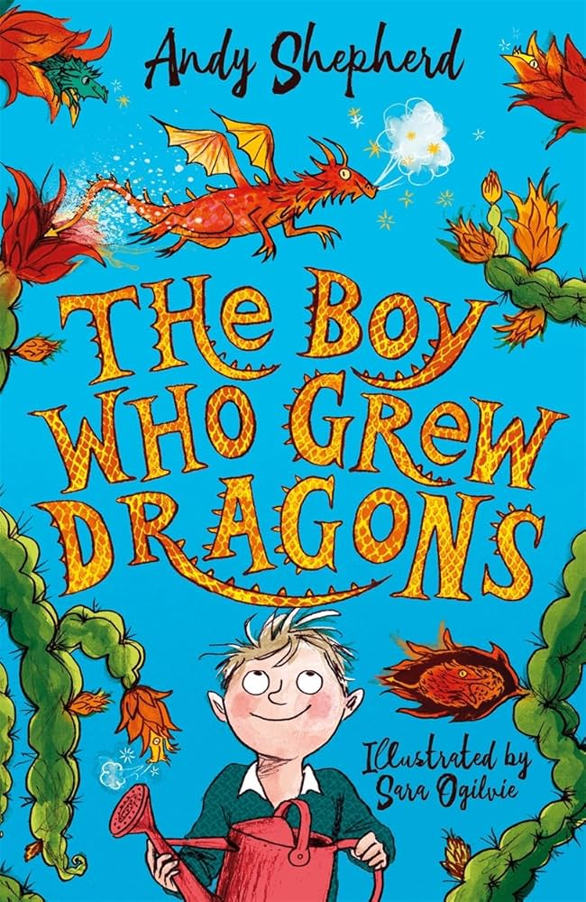 | 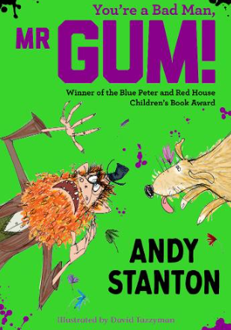
Non-fiction Focus Text | Stone Circles  Non chronological report  Unit 2 | Sugar: The Facts by the NHS  Information text  Unit 5 | A House of Snow and Ice  Information text  Unit 9 | The Story of Tutankhamun  Explanation text  Unit 14 | Wild Animals to be Banned from Circuses  Newspaper  Unit 16 | Discover the Vikings  Information text  Progress Check 3
Poetry (comprehension) | Night Comes Too Soon  Unit 12 | Performance poetry week
Poetry (pleasure) | Greedy Dog by James Hurley  Wind on the hill by A.A.Milne  The Star by Jane Taylor
Reading for pleasure | Mr Penguin  Diary of a Killer Cat  Where the Wild Things Are

