Year 2 | Autumn |  | Spring |  | Summer
Whole Class Reading Text  (Fiction) | Read Write Inc  Grey books | Leaf  The Owl Who Was Afraid of the Dark | Flat Stanley | George’s Marvellous Medicine | Einstein the Penguin | Resue on Nims Island
Whole Class Reading Text  (Fiction) | 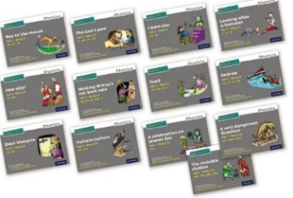 | 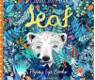  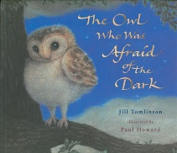 | 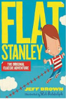 | 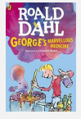 | 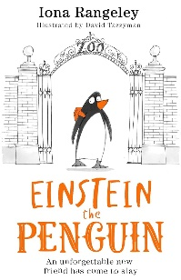 | 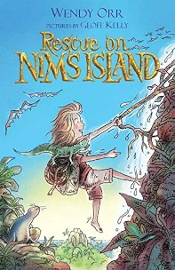
Non-fiction Focus Text |  |  |  |  | 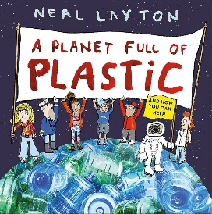
Poetry (comprehension) |  | Performance poetry week
Poetry (pleasure) | Harvest Time is Here Again  by Anita Killick | Cats Sleep Anywhere  by Eleanor Farjeon | Perfectly Peculiar Pets book  by Elli Woollard | The morning rush  by John Foster | An Emotional Menagerie book  by The School of Life
Reading for pleasure | The Enchanted Wood  Hotel Flamingo  Daisy Goes to London  Tiddler

