Tuesday 10th February 2026
Dear Parents and Carers,
Welcome to our latest newsletter. It has been a pleasure to see so much fabulous learning taking place across the school over the past few weeks. The children have continued to show enthusiasm, curiosity, and a positive attitude towards their learning, and we are very proud of their efforts.
Last week, Year Four began their swimming lessons, and they thoroughly enjoyed every session. It was wonderful to see the children learning in a different environment and approaching a new challenge with confidence and determination. Swimming is such an important life skill, and the children worked extremely hard while supporting and encouraging one another throughout the lesson.
Across school, classes have been busy taking part in a wide range of learning activities. Children have been engaging well in lessons, demonstrating resilience and a willingness to try their best. It has been lovely to see them applying their skills and knowledge in creative and practical ways.
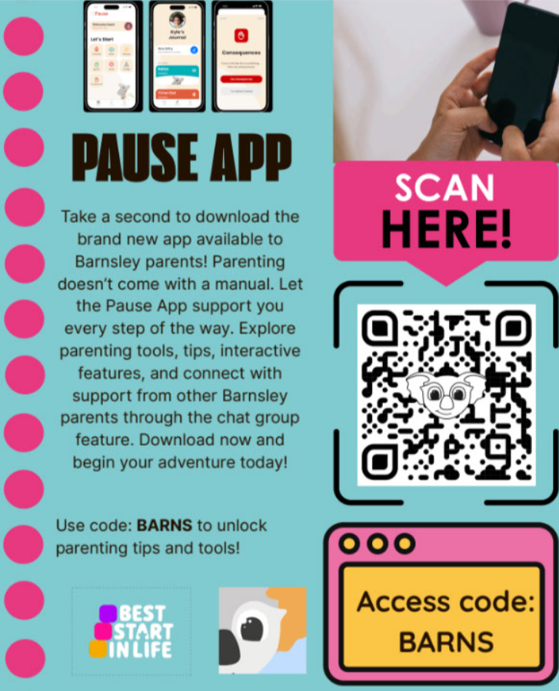
School Communications Update
We will soon be moving to Dojo as our main communication platform. This change will allow us to share school updates, important messages, and information more efficiently with families. Further details, including how to access the platform, will be shared after half term. Thank you for your understanding and patience as we prepare for this transition.
Parenting Support
Please see the attached poster for parenting support from the Pause app. This is a newly launched app designed to support parents and carers with advice, guidance, and helpful resources. We hope families find this a useful source of support.
Egg-cellent Egg Competition! 🥚🎨
We are excited to announce a fun and creative competition for all children! Pupils are invited to decorate an egg by turning it into a character or part of a scene. This could be a favourite book or film character, a superhero, an animal, or even a mini scene from a story – the choice is yours!
Entries should be brought into school on 26.03.26. Eggs can be hard-boiled or made from alternative materials, but please remember that they should be clearly labelled with your child’s name and class.
There will be prizes for the most creative entries, and all eggs will be displayed in school for everyone to enjoy. We can’t wait to see your egg-cellent creations!

Key Diary Dates

February

Thursday 12.02.26 – Swimming starts for Year 4

Friday 13.02.26 – Last Day of Spring One half term
Monday 16th – Friday 20th February February Half term

March
23.02.26 School reopens for Spring Two

Tuesday 3.03.26 – Parent Consultation Evening F2- Y6

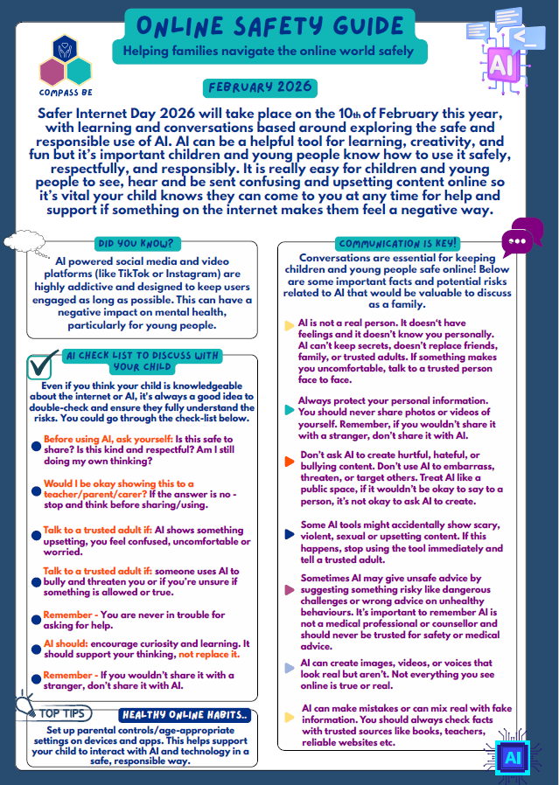
Wednesday 4.03.26 – Parent Consultation Evening Y1- Y6

Thursday 5.03.26 – World Book Day- dress as your favorite book character

Wednesday 18.03.26 – Class Photos
Tuesday 24.03.26 Rocksteady Concert 10:00am start
Thursday 26.03.26 Egg Competition Day!

Friday 27.03.26 – Last Day of Spring Term
Monday 30th March – Friday 10th April Eater Holidays

April

Wednesday 15.03.26 – Compass B Coffee Morning

Thank you for your continued support and we look forward to continuing to work in partnership with you.
Ms R. Steele and the St John’s Team

