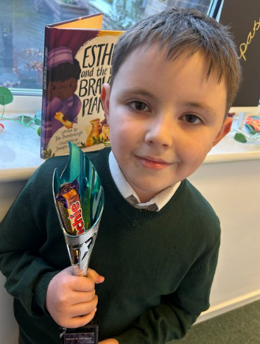
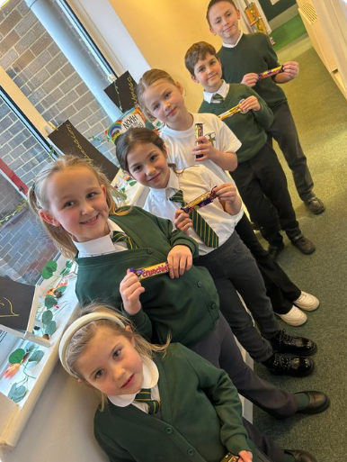
Monday 12th January 2026
Dear Parents and Carers,
Happy New Year and welcome to our first newsletter of 2026. I hope everyone enjoyed a restful and enjoyable break.
It has been wonderful to welcome the children back to school and to hear about their many exciting adventures and stories from the holidays. It was also lovely to see some of you at our Compass B Coffee Morning this week—we hope those who attended found it helpful and informative.
As we begin the new year, we would like to remind everyone of the importance of parking and road safety. Please remain vigilant at all times to help keep our whole school community safe. We have been informed by the council that tighter parking restrictions are now being enforced on Vicarage Lane. We kindly ask that all parents and carers adhere strictly to these restrictions to ensure the safety of our children and the children of Parkside.
We would also like to remind parents that, under no circumstances, should the school car park be used. This is essential for the safety of our pupils.
Weather Thankfully, Storm Goretti did not impact us last week. While a small number of schools in Barnsley were closed, we deemed our school site safe and were able to continue as normal—much to everyone’s relief. The forecast for the coming week looks favourable.
In the event of school closure due to snow or severe weather, this information will be shared via text message to parents and carers, on the council website, and via Twitter.

Attendance Matters Our whole-school attendance target for the year is 97%. Every day in school truly counts, and we greatly appreciate your continued support in ensuring that children attend regularly and arrive on time.
Attendance by class so far:
- Reception: 96.8%
- Year 1: 97.3%
- Year 2: 95.8%
- Year 3: 93.0%
- Year 4: 96.2%
- Year 5: 97.2%
- Year 6: 95.6%

Key Diary Dates

Clubs

Monday
Lego Club F2- Year 2 with Mrs. Hague

Tuesday
Choir Club with Mrs. Goodyear Lunch time
Multi-Skills Y1-Y2 Grass Roots Sports
Multiplication Club Y3-Y4 with Mrs. Hague

Wednesday
Art Club Y3-Y6 with Mrs. Hague

Thursday
Craft Club F2- Year 2 with Mrs. Godfree
Invasion Games Y3-Y6 Grass Roots Sports
Friday
Choir Club with Mrs. Goodyear Lunch time
*Places are available- please contact Mrs. Yould on Reception

January

Monday 19.01.26 – Bikeability for Year 5 pupils

Wednesday 21.01.26 – Fire safety Talk Year 3 pupils

February

Monday 02.02.26 – Heights and Weights Check F2 and Y6 pupils

Thursday 05.02.26 – Swimming starts for Year 4

March

Wednesday 18.03.26 – Class Photos

April

Wednesday 15.03.26 – Compass B Coffee Morning
Warm regards,
Ms R. Steele and the St John’s Team
