Monday 17th November 2025
Dear Parents and Carers,
Welcome to our latest newsletter.
It has been another busy week, and we have some fantastic things to share. In weeks such as this, the sense of pride across our school is enormous. I am hugely privileged to lead a staff team who are incredibly dedicated to the most deserving children and families one could hope to meet.
I attended St John’s Church for the Remembrance service alongside the School Council and Year Six. After the event, I was delighted to receive some wonderful messages praising how beautifully our pupils represented the school. As ever, it was a time for reflection. Thank you to Mrs Bailey for preparing our school wreath, which contributed to a terrific collection from across the local community.
Father Craig reflected on what the fallen may have wished for—kindness and compassion were key themes. These values link perfectly to our school ethos and are lived every single day by our fantastic children. Pupils in school also took part in an assembly; their marking of the silence was excellent.

NSPCC
Looking ahead, the week after next brings another important opportunity for our children. We will be hosting an assembly for pupils from Reception to Year 3 on the NSPCC PANTS Rule. This will take place on Wednesday 19th November and will share age-appropriate messages about personal safety. We are extremely passionate about ensuring children understand what personal safety means, and this is a great place to start. If you would like any further information, please visit the NSPCC website Talk PANTS: Conversations to help keep children safe or speak with Miss Bell.
Attendance Matters

Our whole-school attendance target for the year is 97%. Every day in school counts, and your continued support in ensuring children attend regularly and on time is greatly appreciated.

Please remember:

Attendance below 95% is a cause for concern.

Attendance below 90% is classed as persistent absence.

Attendance by class so far:

Whole school attendance so far this year 96.3%
- Reception: 97.0%
- Year 1: 97.3%
- Year 2: 95.9%
- Year 3: 93.7%
- Year 4: 97.5%
- Year 5: 98.3%
- Year 6: 95.6%
Well done to Reception Class for having the best attendance in the last 7 days 99%.
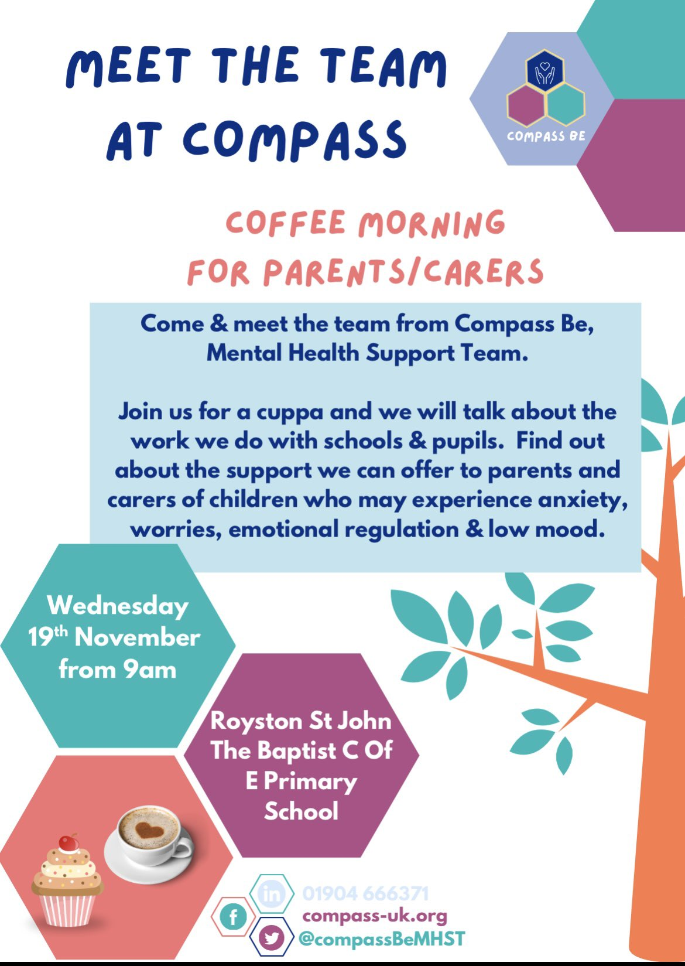
Warm regards,
Ms R. Steele
Headteacher

Key Diary Dates We will continue to add diary dates as we have them.
November
- Wednesday 19.11.25 – Compass B Coffee Morning
- Wednesday 19.11.25 – NSPCC Assembly for Reception to Year 3.
- Friday 28.11.25- Dress down day chocolate donations
December
- Monday 01.12.25 – Year 6 ‘Crucial Crew’ Trip to Life Wise Centre
- Monday 01.12.25 – Choir to sing at Royston Ward Alliance 5pm Parents and carers welcome
- Tuesday 02.12.25 – Christingle at St John’s Church – 2pm (All parents and carers welcome)
- Friday 05.12.25 – Dress down day bottle donations
- Tuesday 09.12.25 – Rocksteady Concert (For parents and carers of children in Rocksteady)
- Wednesday 10.11.25- Christmas Fayre 3:30pm onwards
- Thursday 11.12.25 – Christmas Dinner Day/ Christmas jumpers can be worn with uniform
- Monday 15.12.25 – Year 2/ Year 3 Nativity 2pm
- Tuesday 16.12.25 – KS2 Choir to sing at Gathering Mass – 1:30pm (All parents and carers of choir members welcome)
- Wednesday 17.12.25 – Year 4 and 5 Christmas around the world 9:30am
- Wednesday 17.12.25 – Reception and Year 1 Nativity at St John’s Church. Year 6 to narrate – 2pm (All parents and carers of Reception and Y1 welcome)
- Thursday 18.12.25 – Year 2/ Year 3 Nativity 9:30am
- Thursday 18.12.25 – Year 4 and 5 Christmas around the world 2:00pm
- Friday 19.12.25 – Last Day of Autumn Term- Christmas party Day!

