Tuesday 16th December 2025
Dear Parents and Carers,
Welcome to our latest Newsletter.
The fantastic chaos of the festive season is certainly upon us! An enormous thank you to everyone who has contributed to our Christmas Fayre. Led by Miss Bell and Mrs Bailey (as ever, our sincere thanks to them), the level of support has been nothing short of fantastic by all the staff team and the community.
Thanks to everyone’s generosity and hard work, the school raised an amazing £1,250. As I’m sure you’ll appreciate, this makes a significant difference in supporting our school and its pupils.

We really do hope to see you at the Christmas Concerts this week, as we come together to celebrate the season. Below is a flavour of the festive fun already enjoyed at St John’s.
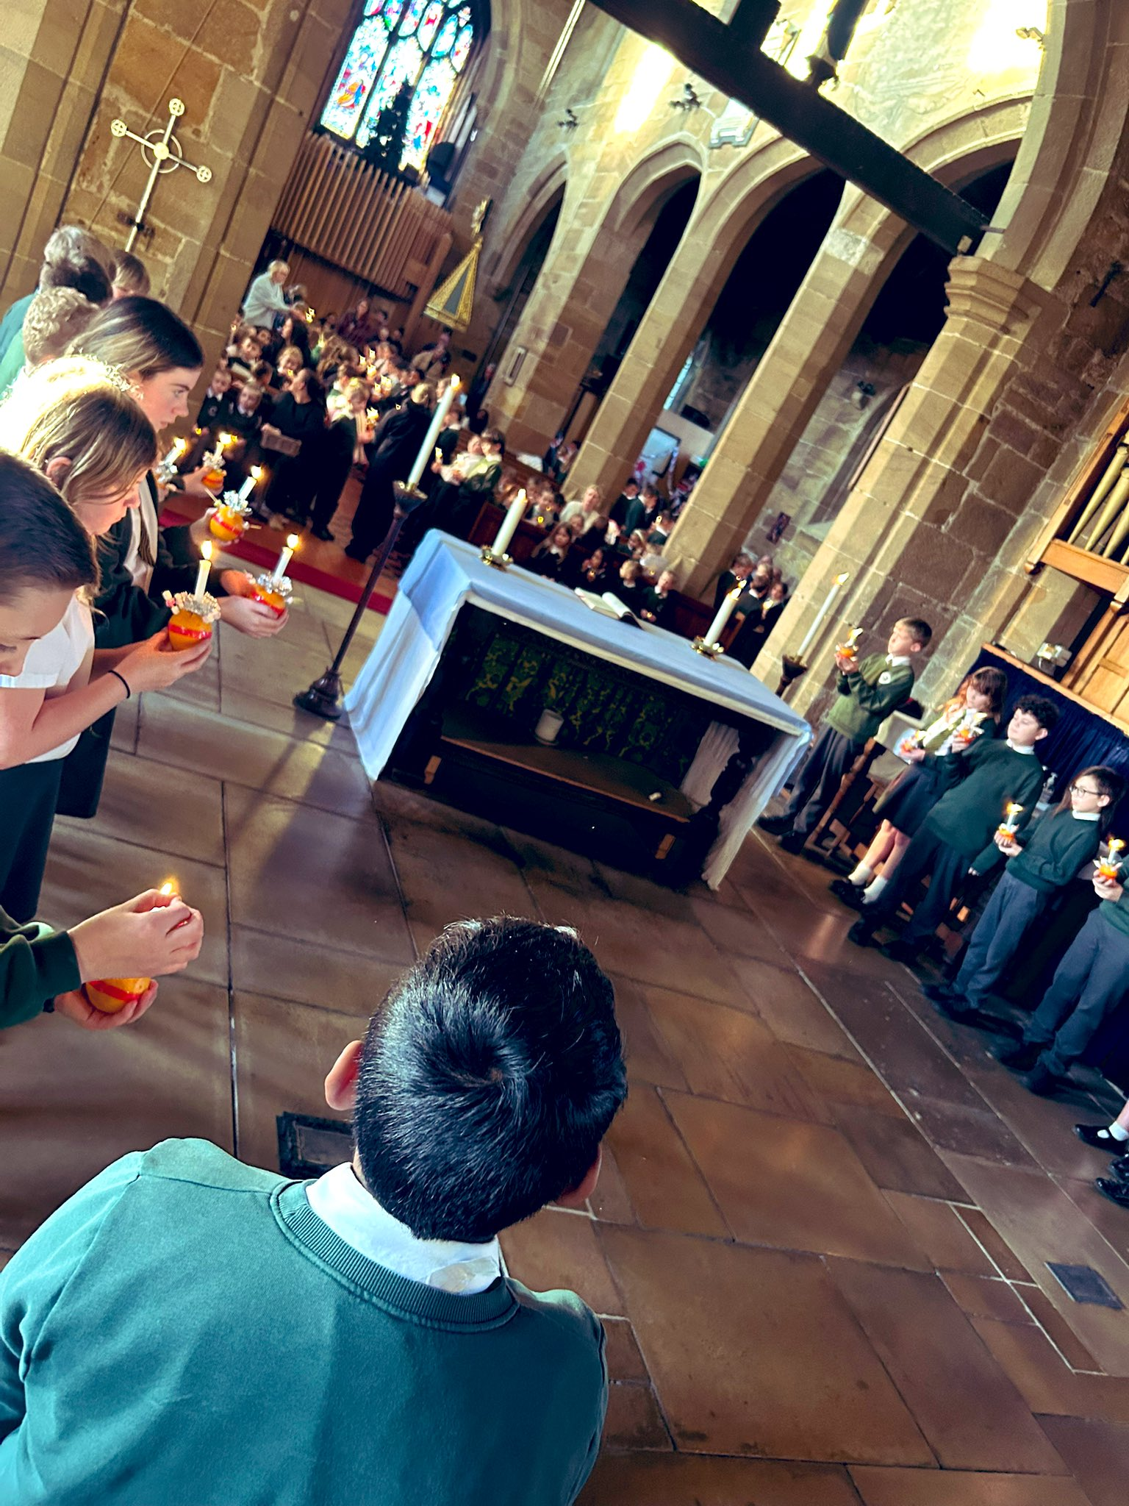
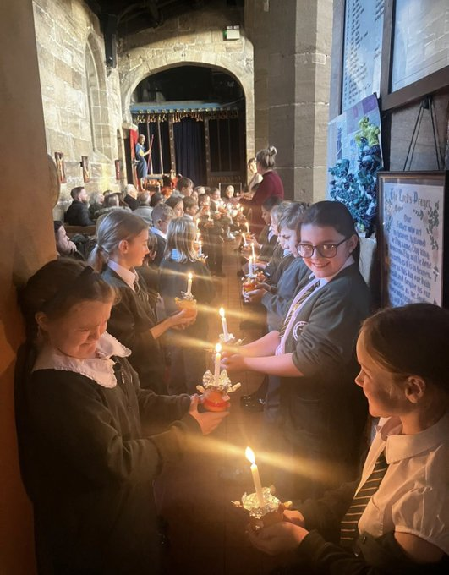
.




Additionally, Mrs Godfree and Mrs Brook have been checking on the progress of our early readers this week. Phonics assessments have gone well, and I am very proud of the reading provision in place at St John’s – well done everyone.
Last year, we achieved our best-ever phonics results, and this year we are hoping to surpass them.
Staffing
As we near the end of the academic year we would like to take this opportunity to share some staffing changes as we start the spring term. We would like to thank Miss Moody for her hard work and dedication as the Year 5 class teacher. Miss Moody will be leaving St John’s at the end of the Autumn Term, and we are extremely grateful for the commitment, care, and enthusiasm she has shown to both the pupils and the wider school community during her time with us. We wish her every success in the next chapter of her career.
As a result of this change, Miss Bell, currently our Year 2 teacher, will be moving into the role of Year 5 class teacher. We are confident that Miss Bell’s KS2 experience and dedication will ensure a smooth transition of teaching for the children in Year 5. Miss Bell is a familiar face to Year 5 already.
This change means that we will be welcoming Miss Wilkinson as the new class teacher for Year 2. Miss Wilkinson will be with us in school to meet the pupils tomorrow and is keen to get started. We do appreciate that a staffing change in the middle of the year is not ideal this decision has been made to ensure pupils are all well supported. Miss Bell will still play a vital role in Year 2 and work closely with our new Year 2 teacher to ensure continuity of teaching and learning.
We apologise that this news is being shared later than we would normally hope; however, it was important that we first ensured appropriate staffing arrangements were securely in place for the new term.
Warm regards,
Ms R. Steele and the St John’s Team.
Key Diary Dates
December
- Wednesday 17.12.25 – Year 4 and 5 Christmas at the Movies 9:30am
- Wednesday 17.12.25 – Reception and Year 1 Nativity at St John’s Church. Year 6 to narrate – 2pm (All parents and carers of Reception, Y1 and Year 6 pupils are welcome)
- Thursday 18.12.25 – Year 2/ Year 3 Nativity 9:30am
- Thursday 18.12.25 – Year 4 and 5 Christmas at the Movies 2:00pm
- Friday 19.12.25 – Last Day of Autumn Term- Christmas party Day! Children can wear party clothes to school and will take part in party activities in the school day.
- Monday 5th January Inset Day
Pupils will return to school on Tuesday 6th January.

