
Monday 10th November 2025
Dear Parents and Carers,
Welcome back after the half term break — we’ve hit the ground running, as you would expect! We were delighted to have Barnsley Youth Choir in school this week to run workshops for pupils across the school. Pupils in Years 2 and 6 also took part in valuable sessions with the NSPCC.

Next week, we will be holding Parents’ Evening. If you have not yet booked an appointment, please get in touch and we will be happy to arrange one for you.

Attendance Matters
Our whole-school attendance target for the year is 97%. Every day in school counts, and your continued support in ensuring children attend regularly and on time is greatly appreciated.
Please remember:
- Attendance below 95% is a cause for concern.

- Attendance below 90% is classed as persistent absence.
Attendance by class so far:
- Reception: 96.8%
- Year 1: 97.0%
- Year 2: 95.9%
- Year 3: 93.4%
- Year 4: 97.5%
- Year 5: 98.1%
- Year 6: 95.1%
I would also like to highlight an important opportunity coming up — our mental health partner, Compass Be, will be hosting a Coffee Morning on Wednesday 19th November. Please do join us if you can.
Warm regards,
Ms R. Steele
Headteacher
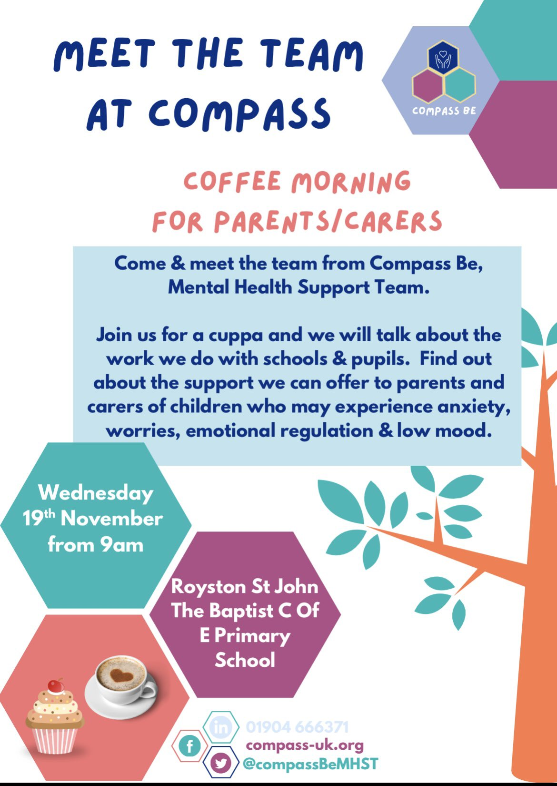
Key Diary Dates We will continue to add diary dates as we have them.
November
- Wednesday 12.11.25- Parents Evening 3-6pm
- Thursday 13.11.25- Parents Evening 3-5pm
- Wednesday 19.11.25 – Compass B Coffee Morning
- Friday 28.11.25- Dress down day chocolate donations
December
- Friday 05.12.25 – Dress down day bottle donations
- Monday 01.12.25 – Year 6 ‘Crucial Crew’ Trip to Life Wise Centre
- Monday 01.12.25 – Choir to sing at Royston Ward Alliance 5pm
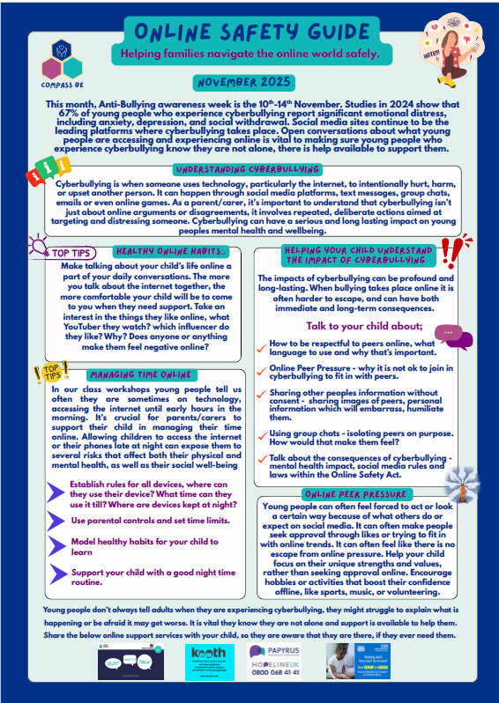
- Tuesday 02.12.25 – Christingle at St John’s Church – 2pm (All parents and carers welcome)
- Tuesday 09.12.25 – Rocksteady Concert (For parents and carers of children in Rocksteady)
- Monday 15.12.25 – Year 2/ Year 3 Nativity 2pm
- Tuesday 16.12.25 – KS2 Choir to sing at Gathering Mass – 1:30pm (All parents and carers of choir members welcome)
- Wednesday 17.12.25 – Year 4 and 5 Christmas around the world 9:30am
- Wednesday 17.12.25 – Reception and Year 1 Nativity at St John’s Church. Year 6 to narrate – 2pm (All parents and carers of Reception and Y1 welcome)
- Thursday 18.12.25 – Year 2/ Year 3 Nativity 9:30am
- Thursday 18.12.25 – Year 4 and 5 Christmas around the world 2:00pm
- Friday 19.12.25 – Last Day of Autumn Term Christmas jumper can be worn with uniform

