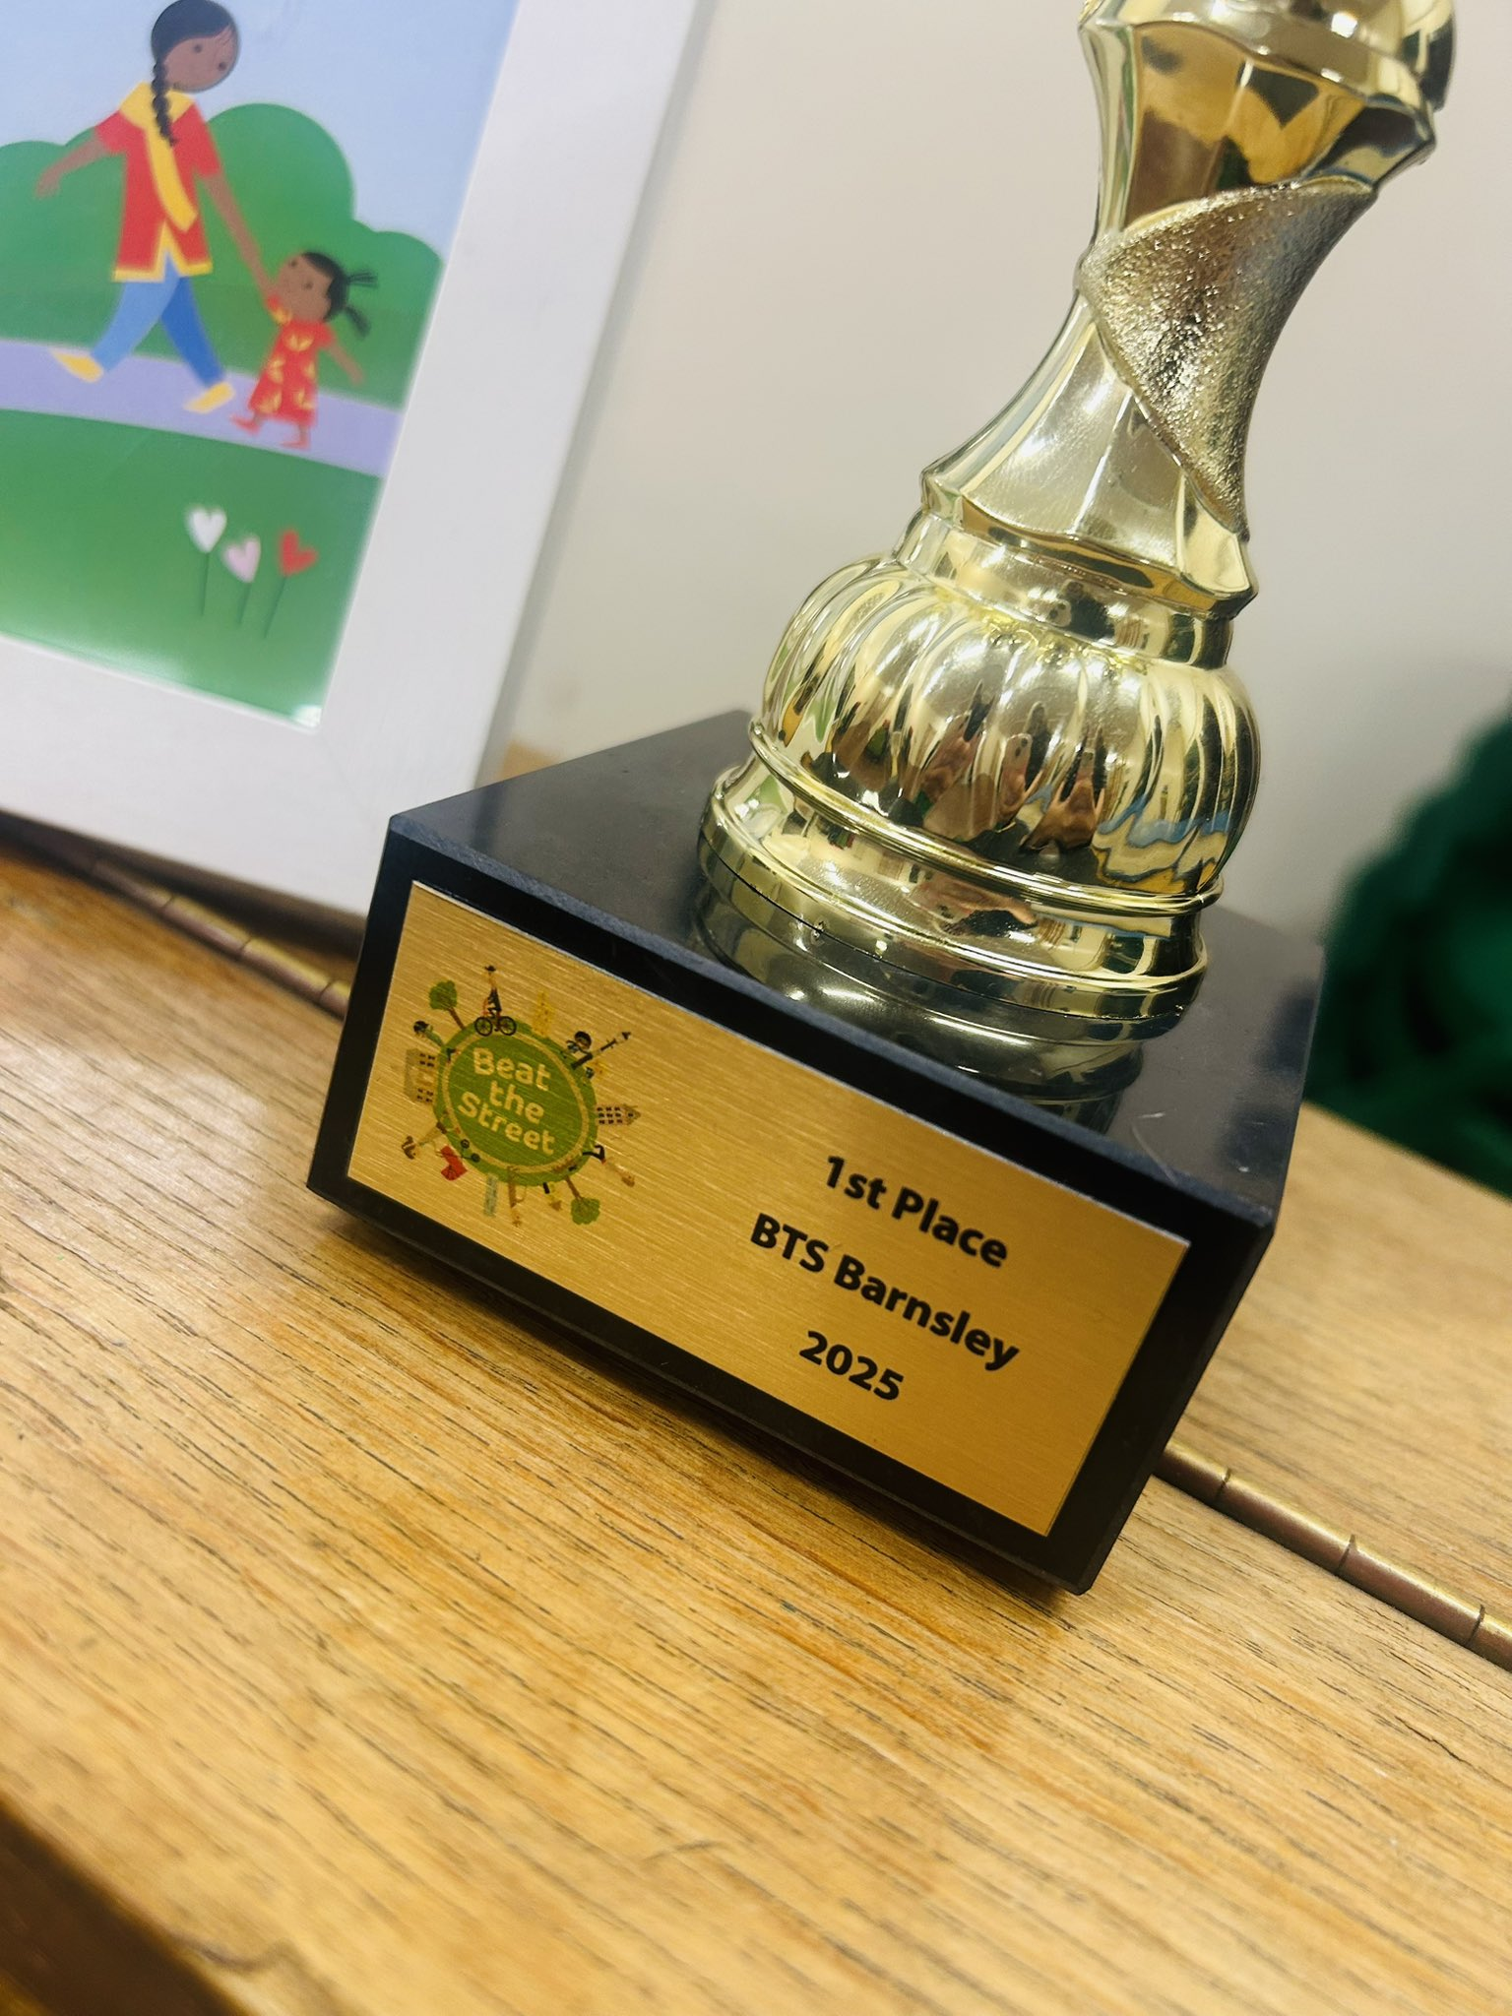
Monday 6th October 2025
Dear Parents/Carers,
I must start with some fantastic news – this week we received our Beat the Street Award from last year! This is a wonderful recognition of the amazing community spirit shown by all our families. A huge thank you to everyone who took part and contributed to our success. This week also saw our Year 6 pupils take part in a Community Safety Workshop. A big well done to them for representing the school so beautifully – we’re very proud! We have also appointed our new peer wellbeing champions who have had training from Compass B. Congratulations to these pupils.

Thank you to all the families who have sent in donations for our Harvest Festival. These will be taken to church on the day of the festival and then donated to local families in need through the Good Food Pantry, supporting those within our own community.

Upcoming Phonics Workshop A reminder that we have a Phonics Workshop for parents and carers of children in Reception and Year 1:
🗓 Thursday 9th October 2025 – 2:30pm
📍 Reception Classroom with Mrs Godfree
Please arrive via the main school office. If you're unable to attend, please speak to Mrs Godfree and she will ensure resources are sent home.

NSPCC Kindness Week & World Mental Health Day It’s NSPCC Kindness Week in school – please check our Twitter page for updates throughout the week.
To celebrate World Mental Health Day on Friday, we’re encouraging pupils to wear something yellow and spread the joy.

Attendance Matters Our whole-school attendance target for the year is 97%. Every day in school counts, and your continued support in ensuring children attend regularly and on time is greatly appreciated.
Here is this year’s attendance by class so far:
- Reception: 96.1%
- Year 1: 96.6%
- Year 2: 94.7%
- Year 3: 94.4%
- Year 4: 97.9% ✅
- Year 5: 98.7% ✅
- Year 6: 94.3%
👏 Special congratulations to Year 4 and Year 5 for exceeding our target!
A quick reminder to all families:
If your child is absent from school, please notify the school office by 9:00am each day. If we are unable to make contact with parents, we will begin calling other listed contacts. If no contact can be made, a home visit will be conducted as part of safe and well checks. Additionally, school will carry out a third-day home visit if your child has been absent for three consecutive days.
Thank you for your continued support, and we look forward to another great week ahead!
Ms. R.Steele
Headteacher
Key Diary Dates We will continue to add diary dates as we have them.
October
- Tuesday Year 5 and 6 Netball at Holy Trinity – selected pupils informed previously 12:30-3:30pm
- Thursday 09.10.25 – Year 1/Reception Parents/Carers Phonics Workshop – 2:30pm
- Friday 10.10.25 – Wear Yellow for World Mental Health Day (Non-uniform)
- Thursday 16.10.25 – Years 5 and 6 ‘Healthy Peer Relationships’ Workshops – Compass B
- Monday 20.10.25 – Individual Photo Day (Siblings not attending school: arrive from 8:30am via the school office)
- Monday 20.10.25 – Harvest Festival at St John’s Church – 2pm (All parents and carers welcome)
- Thursday 23.10.25 – Year 4 ‘Healthy Peer Relationships’ Workshop – Compass B
- Friday 24.10.25 – INSET Day – School closed
November
- Thursday 06.11.25 – BYC Workshops in School – all classes
- Wednesday 19.11.25 – Compass B Coffee Morning
December
- Monday 01.12.25 – Year 6 ‘Crucial Crew’ Trip to LifeWise
- Tuesday 02.12.25 – Christingle at St John’s Church – 2pm (All parents and carers welcome)
- Saturday 06.12.25 – KS2 Choir to sing at the opening of St John’s Church Fayre (Details to follow)
- Tuesday 09.12.25 – Rocksteady Concert (For parents and carers of children in Rocksteady)
- Tuesday 16.12.25 – KS2 Choir to sing at Gathering Mass – 1:30pm (All parents and carers of choir members welcome)
- Wednesday 17.12.25 – Reception and Year 1 Nativity at St John’s Church – 2pm (All parents and carers of Reception and Y1 welcome)
- Friday 19.12.25 – Last Day of Autumn Term

