
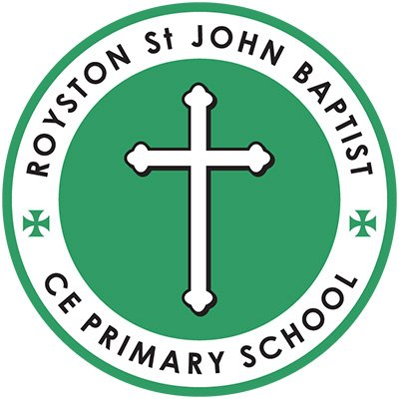

Royston St John Baptist CE Primary

Admissions 2026 - 2027

At Royston St John Baptist CE Primary School, we strive to create a secure and happy environment for all. We are a Christian community who delights in learning, inspires high aspirations and broadens experiences. We learn to love our neighbours as ourselves and stand up for what we believe is right. Through our values and actions, we bring hope into our community and to the future of our world.

Our theological vision is rooted in the parable of The Good Samaritan in which we should “go and do likewise” Luke 10:37.

Contents
1. Introduction 1
2. Making an application 1
3. Admission to School 1
4. Admission procedures 2
5. Normal round applications (Reception September 2026) 2
6. Deferred Entry to Primary Schools 2
7. Admission of Children Outside Their Normal Age Group (Summer-Born) 3
8. Special Educational Needs/Education, Health and Care Plan 3
9. Oversubscription criteria (in priority order): 3
10. Tie Breaker 4
11. Late Applications and Fraudulent Information 4
12 In-Year Admissions. 4
12. Waiting Lists 4
13. Appeals 5
14. Timetable for admission to Primary School 5
15. Appendix 1. SUPPLEMENTARY INFORMATION FORM FOR ADMISSIONS TO ST JOHN’S CE PRIMARY SCHOOL 5
16. Definitions 6

Introduction
At Royston St John Baptist CE Primary School, we strive to create a secure and happy environment for all. We are a Christian community who delights in learning, inspires high aspirations and
broadens experiences. We learn to love our neighbours as ourselves and stand up for what we believe is right. Through our values and actions, we bring hope into our community and to the future of our world.
Our theological vision is rooted in the parable of The Good Samaritan in which we should “go and do likewise” Luke 10:37.
Throughout the policy, the following terms are used:
Admissions Authority
Royston St John Baptist CE Primary School is part of Enhance Academy Trust. The Trust is the admission authority and is responsible for setting the school’s admission arrangements, including the oversubscription criteria. The Local Academy Board for the school oversee this process on behalf of the Trust
Coordination by the Local Authority
Although Enhance Academy Trust is the admission authority, Barnsley Metropolitan Borough Council administers the admissions process on behalf of the school, as part of the coordinated admissions scheme. All applications for a place must be made via Barnsley Council.
Normal Round Applications (Reception September 2026)
Applications for children starting Reception in September 2026 (children born between 1 September 2021 and 31 August 2022) must be made through Barnsley Council’s coordinated admissions process. Applications open in Autumn 2025 and must be submitted by 15 January 2026. National offer day is 16 April 2026, when Barnsley Council will notify parents of the outcome of applications.
Deferred and Part-time Entry
Parents offered a place in Reception may choose to defer their child’s entry until later in the same school year (but not beyond the term after the child’s fifth birthday), or request that their child attends part-time until they reach compulsory school age.
Further information, including the online application form, is available on the Barnsley Council School Admissions webpages.

2. Making an application
Applications for admission to the school should be made by the parent/guardian to the Local Authority via electronic application form between September 2025 and the closing date of 15th January 2026.
If you wish to apply under Christian Commitment Criteria you must obtain a copy of the School’s Information Form (SIF) from the school and return the SIF to the school by the date stated on the form. A copy of this form is attached at Appendix A.

3. Admission to School
Children are admitted to the reception class at the beginning of the school year (i.e. September) in which their fifth birthday falls. Parents offered a place in Reception may choose to defer their child’s entry until later in the same academic year (but not beyond the term after the child’s fifth birthday), or request that their child attends on a part-time basis until the child reaches compulsory school age.
Date of 5th Birthday : 1st September 2021 to 31st August 2022 - start school on the first day school is open following 1st September 2026

4. Admission procedures
The Published Admission Number (PAN) for admission to the Reception class in September 2026 is 30.
The Trust/Academy Board will not place any restrictions on admissions to Reception unless the number of children for whom admission is sought exceeds the number of places available. By law, no infant class may contain more than thirty children.
If there are more applications received than places available during the normal admissions round, the Trust/Academy Board applies the following criteria in strict order of priority, which is determined by the Trust/Academy Board.
The Local Authority operates a co-ordinated admissions scheme and administers a system of equal preferences under which all applications are considered equally and the school’s Academy Board allocates the available places in accordance with its published admissions policy. In the event that there are more applications than places available, the Academy Board will allocate places using the criteria on page 4, which are listed in order of priority. The Local Authority will inform parents of the offer of a place on behalf of the governors on the national offer date - 16th April 2026.
5. Normal round applications (Reception September 2026)
Applications for children starting Reception in September 2026 must be made through Barnsley Council’s coordinated admissions process. Applications open in Autumn 2025 and must be submitted by 15 January 2026. National offer day is 16 April 2026, when Barnsley Council will notify parents of the outcome.
Further details and the online application form are available on the Barnsley Council School Admissions webpages.

6. Deferred Entry to Primary Schools
Where the Academy Board offers a place at a primary or infant school, a parent who accepts that school place can defer entry to that school until the term after the child’s fifth birthday. There may be spring and summer term admissions as a result of parents who have deferred their child’s entry. Any deferred place at the school will be held for that child and will not be available to be offered to another child and the deferred place must be taken up during the same school year for which the offer of the school place was made and accepted. Entry to a school cannot be deferred to the next academic year or beyond the beginning of the term following the child’s fifth birthday.
Parents can also request that their child attends school part time instead of full time until the child reaches statutory school age. Schools must accommodate such requests where it appears to be in the best interest of the child.

7. Admission of Children Outside Their Normal Age Group (Summer-Born)
Parents may request that their child is admitted outside of their normal age group, including requests for summer-born children (born 1 April–31 August) to be admitted to Reception a year later. Each request will be considered on a case-by-case basis, in the best interests of the child. Parents should apply for a place in their child’s normal age group at the usual time, and submit a request for admission out of age group with supporting information. Where the request is agreed, the application for the following year will be processed in the normal admissions round.

8. Special Educational Needs/Education, Health and Care Plan
St John’s will admit children with statements of Special Educational Needs (SEN) or an Education, Health and Care Plan (EHCP) in which the school is named.

9. Oversubscription criteria (in priority order):
Where the number of applications for School received during the normal admissions round exceeds the admission number of the school the Academy Board will apply the following criteria in strict order of priority
9.1 Children who are ‘Looked After’ by the Local Authority in accordance with Section 22 of the Children Act 1989 (i.e. a child who is in the care of the Local Authority or provided with accommodation by that Authority) and children who were ‘looked after’ but have been adopted or have become subject to residency or child arrangement order or special guardianship order. at the time of admission. This priority includes children who appear to the admission authority to have been in state care outside England and ceased to be in state care as a result of being adopted.
A ‘looked after child’ is a child who is;
- in the care of a local authority, or
- being provided with accommodation by a local authority in the exercise of their social services functions.
9.2 Children who have a sibling attending the school at the same time of admissions (Including half-, step- or adoptive brother or sister).
9.3 Children whose parent(s)/carer(s) are resident within the parish of Royston and who are ‘at the heart of the church’
‘At the heart of the church’
- A regular worshipper. A person who worships at least twice per month for a period of 12 months prior to the closing date for application. The worshipper could be one or both parents or the child. b) ‘Attached to the church’
- A regular but not frequent worshipper. A person who usually attends a monthly family or church parade service or is regularly involved in a weekday church activity including an element of worship.
- A child whose parents have moved to become resident in the parish of Royston having been on the Electoral Roll of another Anglican parish, will qualify upon proof of membership being provided by the priest of that parish
Where the child or parents/guardians have recently moved into the parish, evidence of attendance in the previous church will be required and taken into consideration. A ‘Supplementary Information Form’ (SIF) to provide confirmation of Christian commitment is attached to this policy. The form should be completed and signed by the parent/guardian and Minister of the Church or, during a vacancy, by the Church Warden and returned to the school by the date stated on the form. Failure to complete this form may affect the oversubscription criteria in which your child is placed.
9.4 Children whose parent(s)/carer(s) are resident within the parish of Royston and who are ‘attached to the church’.
9.5 Children resident within the parish of Royston who are members of another Christian Church (a member of Churches Together in England) and who are: (a) ‘at the heart of the church’; or (b) ‘attached to the church’.
9.6 All other children resident within the parish of Royston.
9.7 All other applicants.
Tie-breakers and distance measurement are applied as set out below.

10. Tie Breaker
Where there are more applications than places available within one of the above criteria, applications will be allocated to those living closest to the school.
Where two or more applications have equal priority after applying the oversubscription criteria, places will be offered to the child living nearest the school. Distance will be measured in a straight line from the school’s designated point to the child’s permanent home address using the Local Authority’s GIS measuring system. Where two or more children live at exactly the same distance, the tie-break will be random allocation, carried out in the presence of an independent observer. Each time a place becomes available, a fresh round of random allocation will be undertaken.

11. Late Applications and Fraudulent Information
Applications received after the published closing date will normally be considered after those received on time. The school reserves the right to withdraw an offer where it is discovered that misleading or fraudulent information has been given which has effectively denied a place to another child.

12 In-Year Admissions.
The school also participates in Barnsley Council’s Fair Access Protocol. In certain cases, a place may be allocated under the Protocol outside the normal arrangements.
Applications for admission to any year group outside of the normal admission round (in-year) admissions are coordinated by Barnsley Council. Parents should complete Barnsley Council’s in-year application form, available on the Council’s website. Decisions will be notified in writing within 15 school days. Where a place cannot be offered, parents will be advised of their right to appeal.

12. Waiting Lists
Where an application is refused, the child’s name will be placed on a waiting list. Waiting lists are maintained until at least 31 December of the admission year. Each time a child is added to the list or the list is re-ranked, places will be ordered strictly in accordance with the oversubscription criteria, not the date the application was received.

13. Appeals
Where the Trust/Academy Board is unable to offer a place because the school is oversubscribed, parents have the right to appeal to an independent admission appeal panel, set up under the School Standards and Framework Act, 1998, as amended by the Education Act, 2002.
Parents who intend to appeal must submit a notice of appeal within 20 school days of the date of notification of refusal.
Admission Appeal Clerk
Church of England Voluntary Aided Schools and Academies
PO Box 1694
Huddersfield
HD1 9DL
Telephone: 07949707868
Email: churchschoolappeals@gmail.com

14. Timetable for admission to Primary School
- Closing date for receiving applications 15 January 2026
- Offer day 16 April 2026
- Appeals completed End of Summer Term 2026 Appendix A.

15. Appendix 1. SUPPLEMENTARY INFORMATION FORM FOR ADMISSIONS TO ST JOHN’S CE PRIMARY SCHOOL
This Supplementary Information Form should be completed by the parent/guardian of the child who is seeking admission to the school. This form need only be completed to confirm and verify that you meet the requirements of the oversubscription criteria related to church attendance. No additional information will be considered unless a family has attended more than one place of worship for that period, in which case more than one form may be submitted to cover the two years. It is the responsibility of the parent to get both sections complete and returned to school.
The Supplementary Information Form is used only to apply the school’s faith-based oversubscription criteria. Completion of the SIF is optional and it will not be used for any other purpose.
This form should be returned to the school office by no later than midnight on 15th January 2026
Section A: Application for admission to St John Baptist CE Primary School.
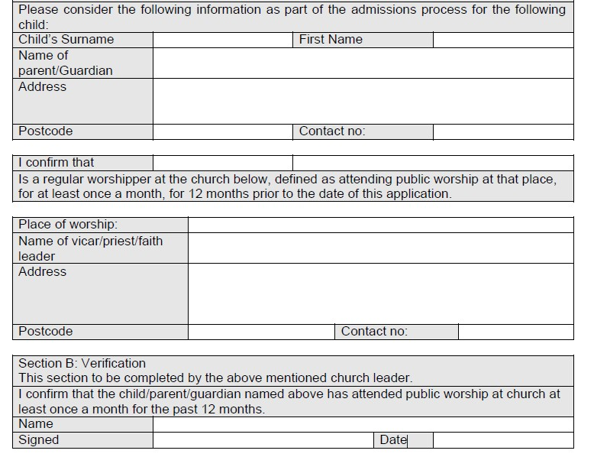

Timetable

for

admission

to

Primary

School

Closing

date
for

receiving
applications

15

January

2026

Offer
day

16

April

2026

Appeals

completed

End

of

Summer

Term

20

16. Definitions
Home Address
The child’s permanent address is where they usually live with their parent(s) or legal guardian(s). Where a child lives with parents who have shared responsibility, the address used for admissions purposes will be the one at which the child resides for the majority of the school week. Where there is equal residence, the address of the parent who receives the child benefit will be used. Proof of address may be requested.
Sibling
For admissions purposes, “sibling” means:
- a full, half, step, or adopted brother or sister,
- or a child who is permanently resident in the same household.

Looked After and Previously Looked After Children (LAC/PLAC)
- Looked after child: a child who is in the care of a local authority or being provided with accommodation by a local authority.
- Previously looked after child: a child who was looked after but ceased to be so because they were adopted or became subject to a child arrangements or special guardianship order, including children who appear to have been in state care outside of England and ceased to be in that state care as a result of being adopted.

Distance Measurement
Distance will be measured in a straight line from the designated point of the child’s home address to the designated point of the school, using the Local Authority’s GIS (Geographical Information System).
Tie-breaker
Where two or more applications cannot otherwise be separated, a random allocation process will be used, independently supervised, and repeated each time a place becomes available.
Faith-based Evidence
Where oversubscription criteria include church attendance or membership, evidence will be assessed using the Supplementary Information Form (SIF), which must be submitted to the school by the stated deadline. The SIF is used only to apply the faith criterion.
Child of a Member of Staff (only include if you use this criterion)
Priority may be given to children of staff in either or both of the following circumstances:
- where the member of staff has been employed at the school for two or more years at the time at which the application is made, and/or
- the member of staff has been recruited to fill a vacant post for which there is a demonstrable skill shortage.

the parish of Royston, as defined by the Church of England. A map can be inspected at the school office or online via https://www.achurchnearyou.com
Multiple Births
Where the final place to be allocated would require the admission of twins, triplets, or other multiple-birth siblings, the school will admit all such children, even if this results in the PAN being exceeded.

