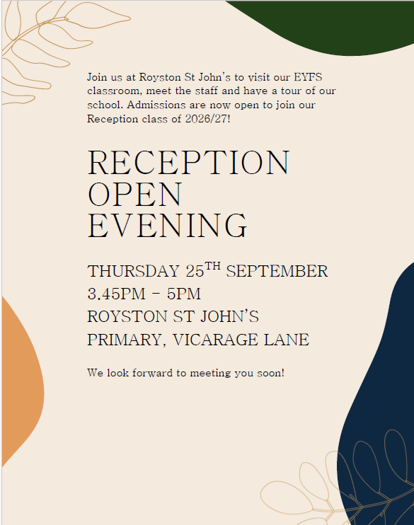Monday 15th September 2025

Dear Parents/Carers,

We’ve had a fantastic first full week back at school, and it’s been a joy to see our younger children and new starters settling in so well. Thank you for all your support in helping make the return to school a smooth one.

If you have a child due to start Reception next year—or know someone who does—please spread the word about our upcoming **Open Night**. It’s a great opportunity to visit our school and meet the team.

**Parent Pay**

We are currently experiencing some issues with **Parent Pay** and are working to resolve them as quickly as possible. We appreciate your patience and will update you as soon as everything is back up and running.

**Attendance Matters**

This year, we’re continuing our focus on improving attendance across the school. Our aim is for every class to meet the **national target of 97% attendance**. Good attendance and punctuality make a huge difference to your child’s progress—**every day really is a learning day**.

* If a pupil’s attendance drops below 97%, a member of staff will be in touch to offer support and guidance.
* Please note that, in line with school, Local Authority (LA), and Education Welfare Officer (EWO) guidance, **holidays during term time will not be authorised**.
* Our school term dates and INSET days can be found on the school website, along with information about the attendance policy and fining system.

Thank you for continuing to ensure your children arrive on time. Last week, we had just **four late marks** across the whole school, and we’re aiming for **zero moving forward**. A smooth start to the day helps every child—and every class—begin with confidence and focus.

* **School gates close at 9:00 am**.
* Arrivals after this time must enter via the school office and will be marked as late.
* There is a **10-minute window** to support families in ensuring a timely and calm start to the day.

**Water Bottles & Snacks**

Please ensure your child brings a **water bottle** to school each day. Bottles should contain **water only**, not juice. For children in **KS2 (Years 3–6)**, if they would like a snack at break time, please send **fruit only**. Other snack items will be returned home, as we continue promoting healthy eating across school.

* Sweets are **not permitted** in lunchboxes.
* **Fizzy drinks and milkshakes** are also not allowed.

Thank you once again for your continued support. We’re looking forward to another fantastic year together.

R.Steele

Headteacher

September

**Thursday 18.9.25** Year 4, 5 and 6 ‘Positive journey to Mental Health’ workshops- Compass B

**Friday 19.9.25** Year 1 ‘This is Me!’ workshop- Compass B

**Thursday 25.9.25** EYFS Open night for pupils starting next September

**Friday 26.9.25** Amaze Lab Stem workshops- all classes

October

**Thursday 02.10.25** Flu spray day (If consent given via NHS)

**Thursday 02.10.25** Year 6 Community Safety Day

**Thursday 09.10.25** Year 1/ Reception Parents/ carers Phonics workshop 2:30pm

**Friday 10.10.25** Wear Yellow for World Mental Health Day (Non- uniform)

**Thursday 16.10.25** Years 5 and 6 ‘Healthy Peer Relationships’ workshops- Compass B

**Monday 20.10.25** Harvest Festival at St John’s Church 2pm (All parents and carers welcome)

**Thursday 23.10.25** Year 4 ‘Healthy Peer Relationships’ workshop- Compass B

**Friday 24.10.25** Inset Day School closed

November

**Thursday 06.11.25** BYC workshops in school- all classes

**Wednesday 19.11.25** Compass B Coffee Morning

December

**Monday 1.12.25** Year 6 Crucial Crew trip to Life Wise

**Tuesday 2.12.25** Christingle at St John’s Church 2pm (All parents and carers welcome)

**Saturday 6.12.25** KS2 Choir to sing at the opening of St John’s Church Fayre (details to follow)

**Saturday 6.12.25** KS2 Choir to sing at the opening of St John’s Church Fayre (details to follow)

**Tuesday 9.12.25** Rocksteady Concert (For parents and carers of children in Rocksteady)

**Tuesday 16.12.25** KS2 Choir to sing at Gathering Mass  1:30pm (All parents and carers of choir members welcome)

**Wednesday 17.12.25** Reception and Year 1 nativity at St John’s Church 2pm (All parents and carers of R and Y1 welcome)

**Friday 19.12.25** Last day of Autumn Term